Jun Node ko attributes haru lai manipulate garnaa khojdai xam, suru maa tyo node laii taa grab garnai paryoo. Ani balla properties haru apply garinxaa.

**.attributes( )**

**We have acouple ways to handle attributes in javascript**

**Method 1**

Every node object has this property

It returns us the NamedNodeList which is a number object containing node objects of attribute node type

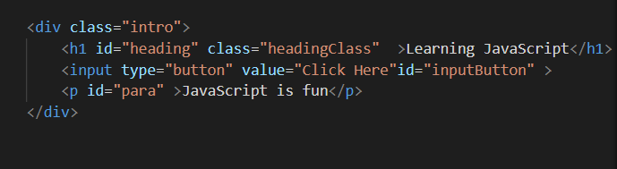

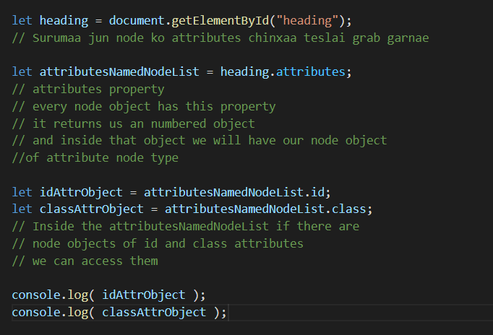

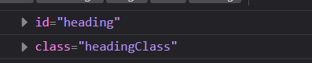

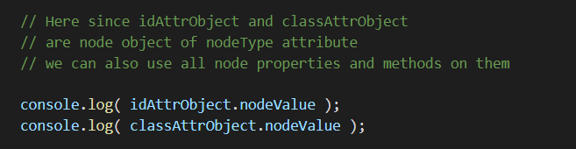

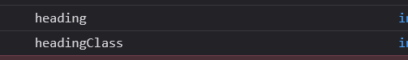

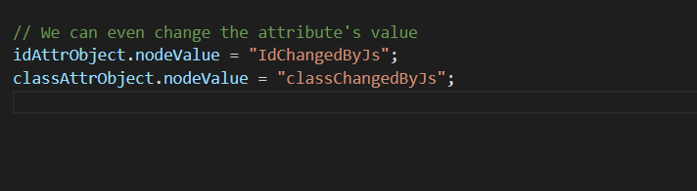

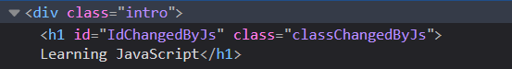

**Method 2**

It seems simple, handy and easy to remember

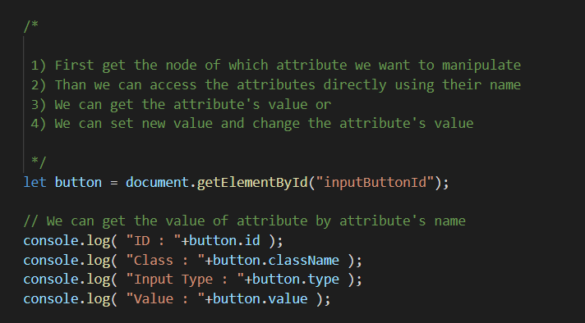

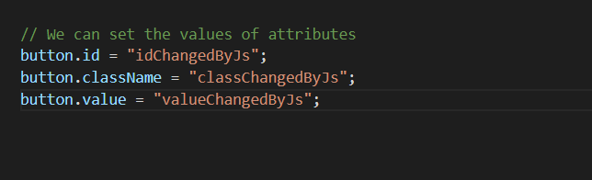



**Method 3**

Easy to remember and handy method

Just remember three methods

**Every node of the DOM tree has these methods**

.getAttribute( )

.setAttribute( )

.removeAttribute( )

**.getAttribute() method**

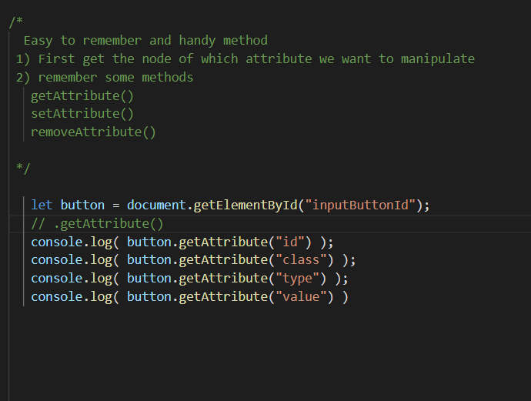

**.setAttribute ( ) method**

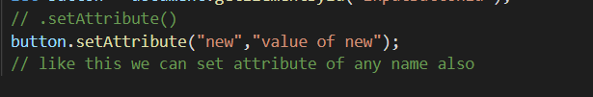



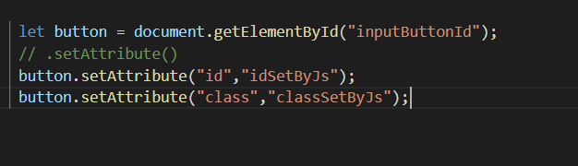



**.removeAttribute( ) method**

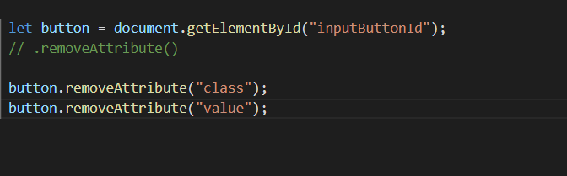



See “class” and “value” are removed

**.hasAttribute( )**

It returns true or false depending upon whether the node has the specified attribute or not

